St Patrick’s P.S Drumgreenagh  40, Longstone Hill Road,  Drumgreenagh,  Rathfriland.  County Down  BT34 5BT  Phone: 028406 30587 Email: nmagee351@c2kni.net  Principal: Mrs N Magee | 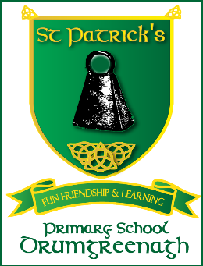
30th March 2021
Dear Parents/ Guardians,
Thank you so much for your generous support of our charity fundraiser – the total amount raised will be split between Trocaire and Cancer Research.
Easter Break
The school closes at 11.30 am on Thursday 1st April for the Easter break and reopens on the 12th April. The children may wear their own clothes to school on Thursday.
EZ Payments App
Details for linking cards to the EZ Payments app are available on Parent Information section of the school app and on the school website www.stpatricksdrumgreenagh.com - Parents Area – School Forms.
Children in receipt of Free School Meals do not need to book their meals online.
First Confession
The Primary Four children will make their First Confession in school very soon, details will be sent home as soon as they become available. Primary Four parents are asked to continue to revise the prayers for First Confession with their children.
First Holy Communion and Confirmation
We are waiting on information regarding congregation numbers which will inform the arrangements for First Communion and Confirmation. The original dates remain unchanged-
- First Communion: Saturday 15th May
- Confirmation: Friday 21st May
Further details will be sent home as soon as they become available.
Primary Six/Seven Cycling Proficiency
Cycling proficiency classes for the Primary Six/Seven classes will commence after the Easter break. Please ensure that your child’s bike is in a roadworthy condition. Participating children MUST wear a cycling helmet.
Thank you so much for your support and encourgement. We hope you all have a happy and peaceful Easter.
Yours sincerely,
Mrs N. Magee and staff

