St Patrick’s P.S Drumgreenagh  40, Longstone Hill Road,  Drumgreenagh,  Rathfriland.  County Down  BT34 5BT  Phone: 028406 30587 Email:nmagee351@c2kni.net  Principal: Mrs N Magee | 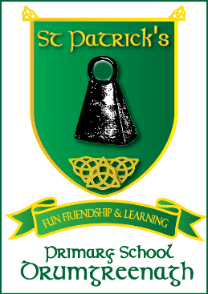

11th May 2021

Dear Parent/ Guardian,

We hope you enjoyed the recent break despite the cold weather.

Thank you for your support of the recent bookfair. The total amount of books sold was £800 and this will generate £300 of books for our school.

The Lenten campaign raised £710 – thank you. On behalf of the school a cheque for £350 for Trocaire was presented to Fr Charlie and £360 was transferred to Cancer Research. Well done – this was a tremendous effort!

Sacraments
First Holy Communion will take place on Saturday 15th May at 10am in St. Colman’s Church. Confirmation will take place on Friday 21st May at 4pm. As the number who can attend in person is limited we hope to stream these ceremonies through the Drumgath Parish Facebook page.

The school will close for all children at 1pm on Friday 21st May

Retirement of Mrs M Grattan

Mrs M Grattan has retired from her postion as school clerical officer. Mrs Grattan has been a very valued and dedicated member of the staff of St Patrick’s since the school opened in 1998. To mark the occasion of Mrs Grattan’s retirement we would like to present her with a gift on behalf of the children of St Patrick’s. If you would like to contribute to the presentation please send your donation to the school office in a clearly marked envelope on or before the 28th May.

Sports Day
Sports day has been scheduled for Friday 11th June (weather permitting). Unfortunately, due to the current restrictions, spectators cannot attend.

Primary Seven Leaving Ceremony
The Primary Seven leaving ceremony is scheduled to take place on Friday 25th June at 1pm.

We would like to offer our sincere sympathy to the Tomasiuk family on their recent bereavement.

And finally, we wish our Primary Three pupil, Bryan Niziolek, well as he begins his new school in St. Patrick’s, Newry – we hope he will be very happy.

As always, we thank you most sincerely for your support and cooperation. If you require any further information or wish to speak to your child’s teacher please do not hesitate to contact us.

Yours sincerely,

Mrs N. Magee and staff

Diary Dates

Monday 31st May: School Closed
Tuesday 1st June: Staff Development Day ( School closed)

Friday 11th June: Sports Day
Friday 25th June: Primary Seven Leavers’ Ceremony

