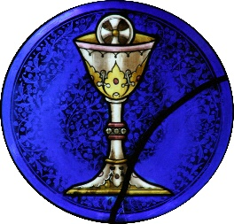**Important Dates: 2021-2022**

First Confession: Tuesday 8th March (time to be confirmed)

First Holy Communion: Saturday 21st May 2022 @ 10.30 am

Confirmation: Friday 13th May 2022@ 4pm