St Patrick’s P.S Drumgreenagh  40, Longstone Hill Road,  Drumgreenagh,  Rathfriland.  County Down  BT34 5BT  Phone: 028406 30587 Email:nmagee351@c2kni.net  Principal: Mrs N Magee | 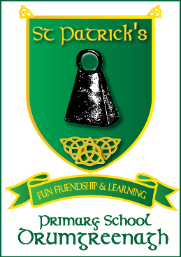

CONCUSSION AWARENESS – WHO NEEDS TO KNOW?

Dear Parent/ Guardian,

The Department of Education has requested that all schools should write to parents/guardians to highlight the need for you to keep all organisations informed if your child receives a concussion injury.

Concussion is a brain injury which is usually caused by hitting the head or a fall. It can happen at any time, anywhere: for example, during sports, in the school playground, or at home.

Concussion must always be taken seriously and it is vitally important that any child/young person suspected of having concussion should immediately be stopped from continuing whatever activity they are doing and be assessed by a medical professional for diagnosis and guidance. A second injury when a child has concussion can be extremely serious and may even be fatal. It is vitally important therefore that medical clearance is sought before your child returns to school/play. Children should not resume physical activities such as Physical Education (PE), sports or games until permitted to do so by a medical professional.

Concussion may also affect your child‘s ability to learn at school. This must be considered and medical clearance should be sought before the child returns to school. As symptoms vary from child to child, a graduated return to school programme may be needed.

If your child suffers a concussion in school or outside school, it is vitally important that you keep all people/organisations with responsibility for caring for your child informed so that they are aware of the potential dangers and any restrictions that may apply to the activities your child is permitted to do.

The ‘Recognise and Remove’ leaflet produced by the Department of Education and the Department of Culture, Arts and Leisure is available on the Department of Education’s website http://www.education-ni.gov.uk and provides guidance on the signs to look out for. Keeping everyone informed about concussion is in your child’s best interests and parents/guardians have a key role in making sure that information is passed on to their child’s teacher, sports coach, youth leader or other care provider.

Yours sincerely,

Mrs N. Magee

Principal

